Defects Report
(Search + Filter + Sort + Cart + Checkout (E2E))
Defect ID: ECOM-001
Title: Filter Sidebar is Missing on Search Results Page
Feature: Search & Filter
Related Test Case: TC_06
Summary:
Filter sidebar/module is missing from the Search Results page; preventing users from filtering products by price, category, color.
Environment:
- Application: PrestaShop Demo Front Office (Link)
- Browser: Chrome
- OS: Windows 11
Severity: High
Priority: High
Precondition:
- User is on the Search Results page.
Steps to Reproduce:
- Open the PrestaShop demo site.
- Search for any product.
- Navigate to the Search Results page.
- Check for the Filter Sidebar.
Expected Result:
The filter sidebar should be displayed with options such as Price, Category, Color, etc.
Actual Result:
The filter sidebar is missing from the Search Results page.
Status: New
Evidence Screenshot :
Filter Sidebar Not Available -
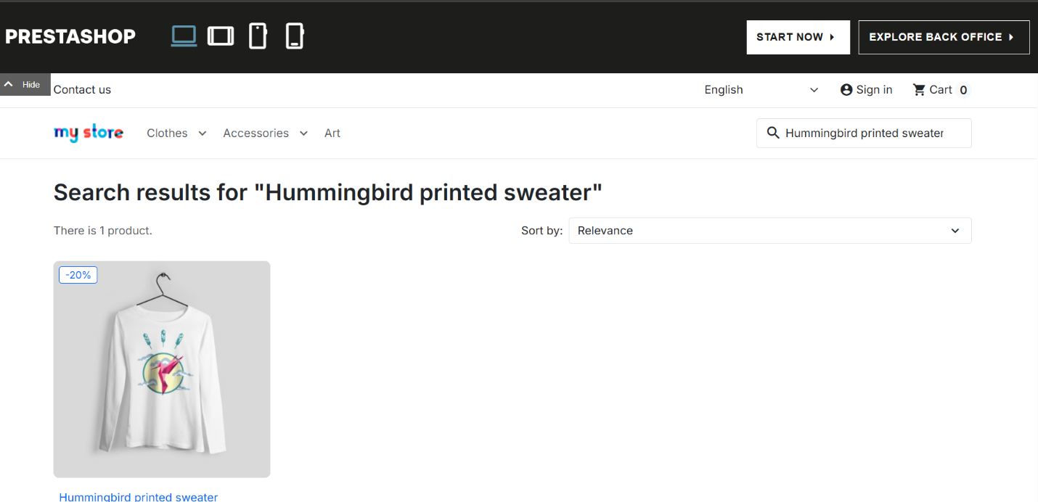

Defect ID: ECOM-002
Title: Multiple Filters Cannot Be Applied Because Filter Options Are Missing
Feature: Search & Filter
Related Test Case: TC_07
Summary:
Users cannot apply multiple filters simultaneously because the filter options are unavailable on the Search Results page.
Environment:
- Application: PrestaShop Demo Front Office (Link)
- Browser: Chrome
- OS: Windows 11
Severity: High
Priority: High
Precondition:
- User is on the Search Results page
Steps to Reproduce:
- Search for any product.
- Open the Search Results page.
- Try to apply Category and Price filters simultaneously.
Expected Result:
The system should allow users to apply multiple filters together and display matching products.
Actual Result:
Filter options are unavailable, so multiple filtering cannot be performed.
Status: New
Evidence Screenshot :

Multiple Filter Not Available -
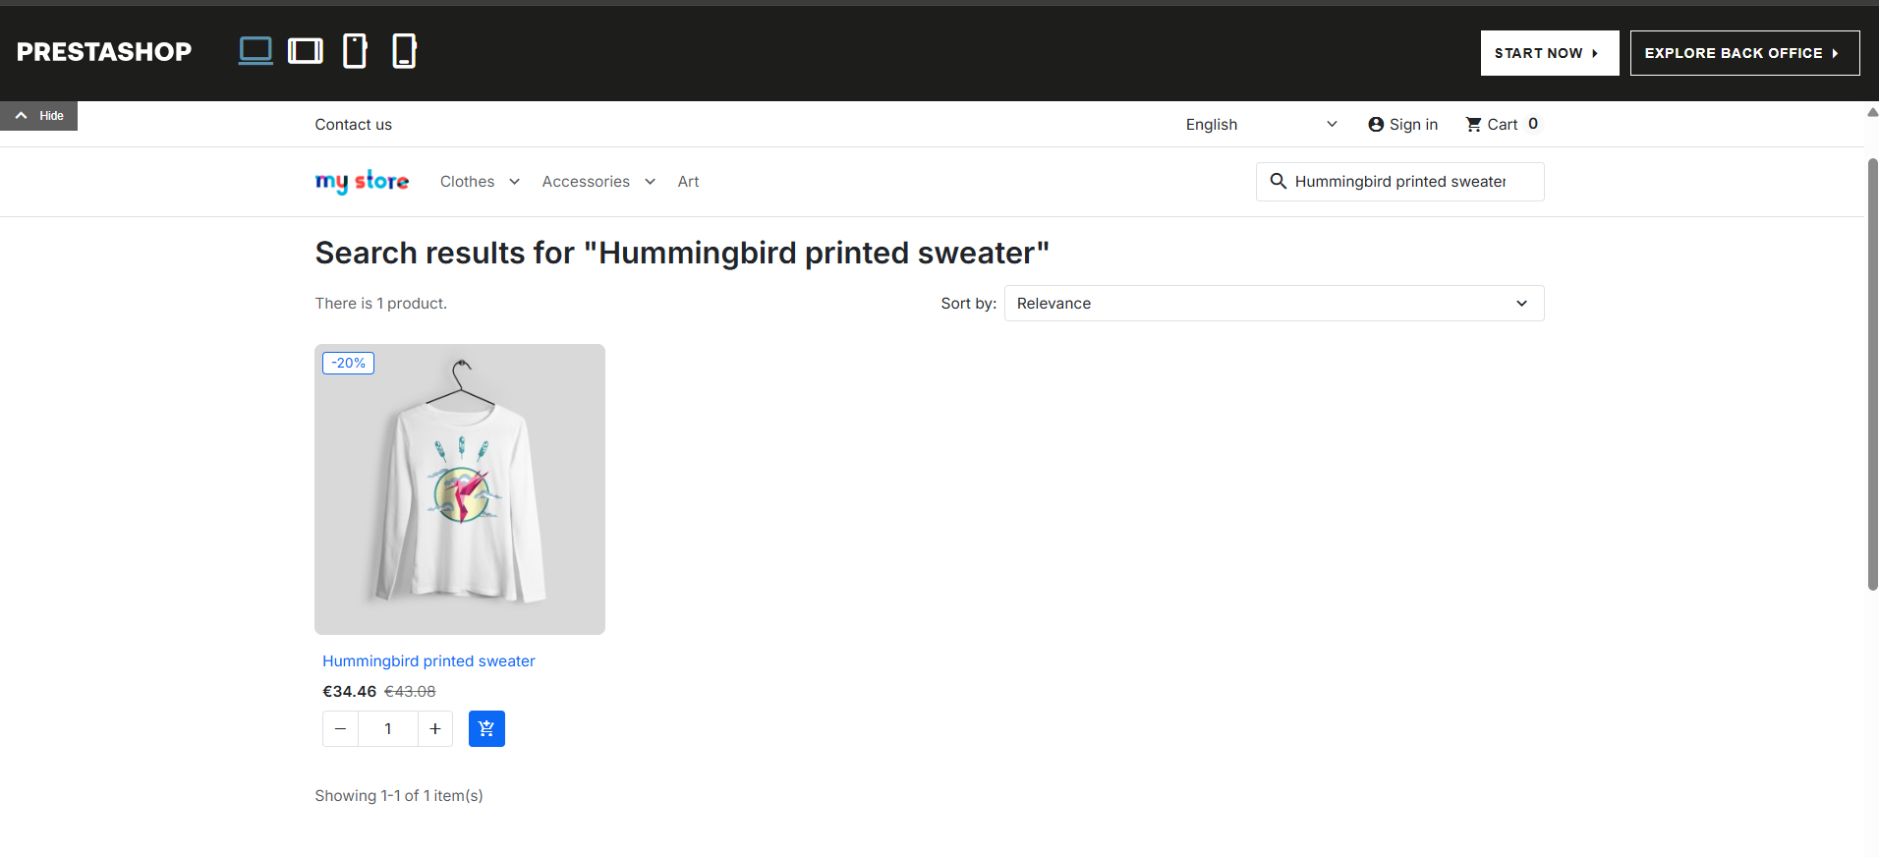

Defect ID: ECOM-003
Title: "Clear All" / "Reset" Filter Option is Unavailable
Module: Search & Filter
Related Test Case: TC_13
Summary:
The Clear All/Reset filter option is unavailable due to missing filter module on the search result page, preventing users from removing applied filters and restoring the default search results.
Environment:
- Application: PrestaShop Demo Front Office (Link)
- Browser: Chrome
- OS: Windows 11
Severity: Medium
Priority: Medium
Precondition:
- User is on the Search Results page
Steps to Reproduce:
- Search for a product.
- Attempt to locate the Clear All or Reset option for filters.
Expected Result:
A Clear All/Reset button should remove all applied filters and restore the original search results.
Actual Result:
The button is unavailable because the filter module is missing.
Status: New
Evidence Screenshot :
